**LARAVEL**

Contents

I.Model 1

+ Xử lý validate 1

+ Join bảng 2

+ Join bảng laravel (table 1 & table 3), qua trung gian table 2 2

+ Validate form laravel 3

II. Controller 5

+ Check user login bằng auth 5

+ Login basic custom 5

+ Login with Auth attempt 5

+ Redirect with param 5

+ Request controller 7

III. View 9

+ Show data khi edit data (old and db data) 9

+ Pass param to view 9

IV. Router 9

V. Code 9

+ Show msg validate khi dung Ajax or API 9

+ Hiển thị log query (Http/Provider/AppServiceProvider) 10

+ Middleware group 10

+ Middleware 1 router 10

VI. API 10

+ Xử lý router 10

+ Status API 11

# I.Model

## + Xử lý validate

**Validate trên controller**

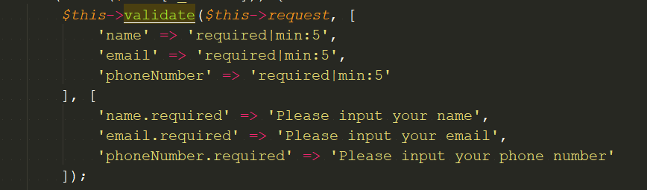

**Validate trong model**

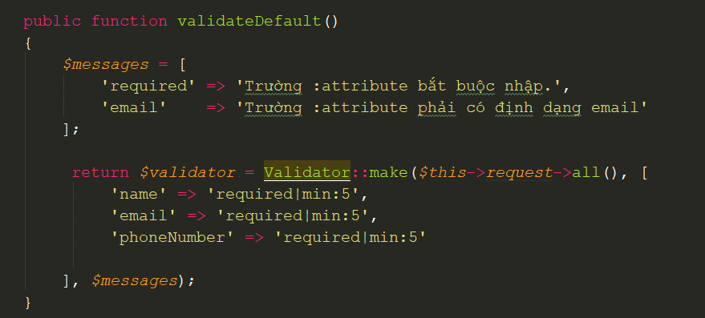

## + Join bảng

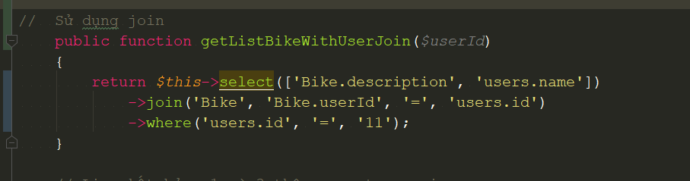

## + Join bảng laravel (table 1 & table 3), qua trung gian table 2

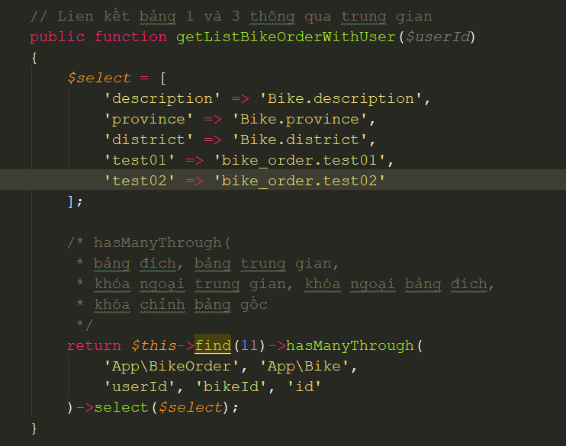

## + Validate form laravel

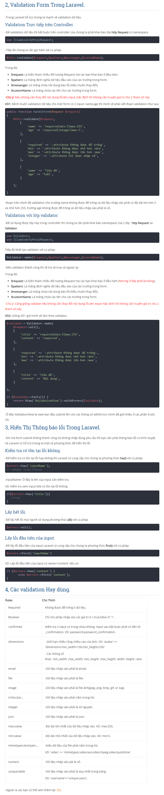

# II. Controller

## + Check user login bằng auth

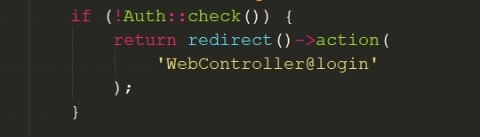

## + Login basic custom

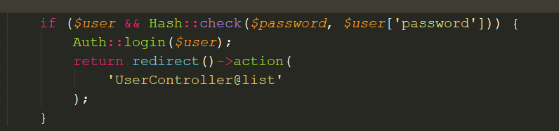

## + Login with Auth attempt

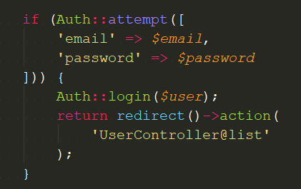

## + Redirect with param

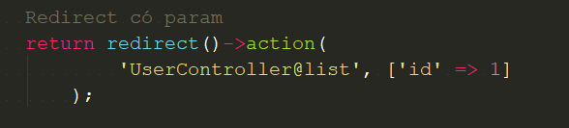

## + Request controller

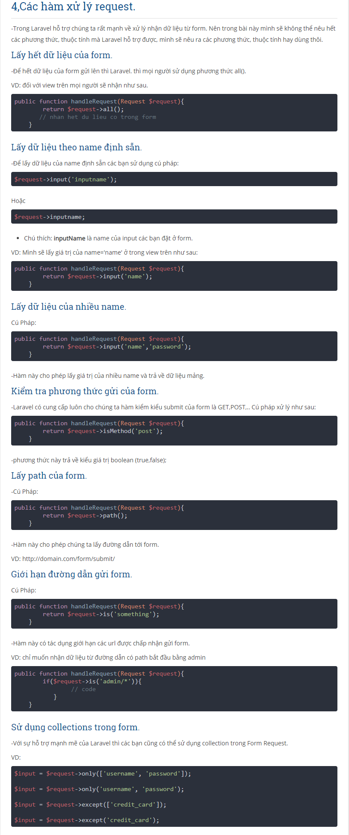

# III. View

## + Show data khi edit data (old and db data)

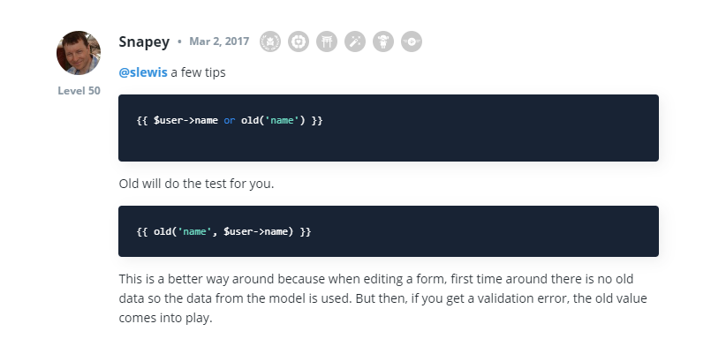

## + Pass param to view

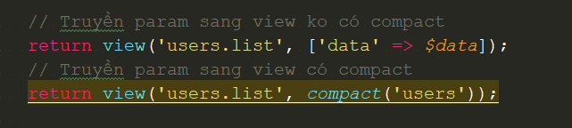

# IV. Router

# V. Code

## + Show msg validate khi dung Ajax or API

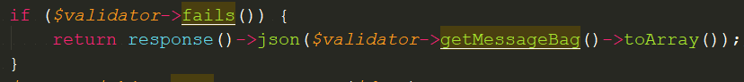

## + Hiển thị log query (Http/Provider/AppServiceProvider)

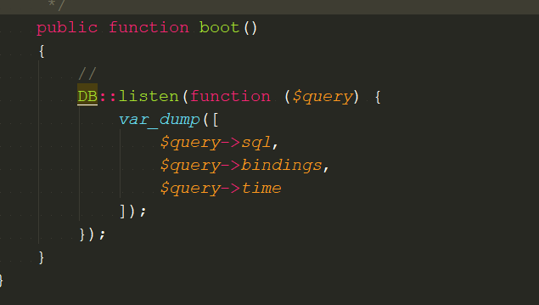

## + Middleware group

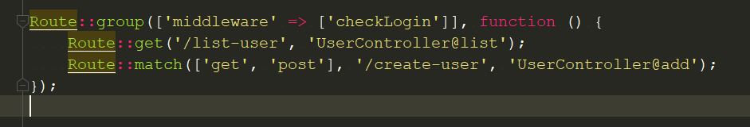

## + Middleware 1 router

**C:\Users\MyPC\Pictures\Laravel\middleware router.png**

# VI. API

## + Xử lý router

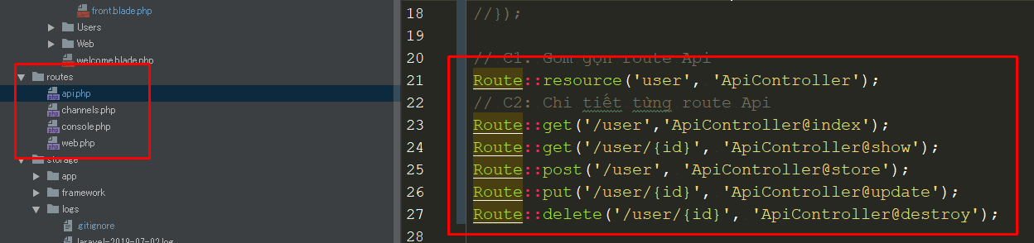

## + Status API

